**PROJECT 3**

**SINDHUJA YERRAMALLA(U00839259)**

**How to run my code:**

* Open the code in any python IDE.
* Run the server file attached.
* And run the client file attached.
* The output displays the client and server start time after that in client console you will observe four columns of numbers which are local clock times of client 1 and client 2(thread 1 and thread 2) without and with Berkeley algorithm respectively.
* Then we can observe another two columns of output which is the local time difference between the two processes without and with Berkeley algorithm.
* And then the close times.

**Analysis of the Output:**

|  |  |  |  |
| --- | --- | --- | --- |
| Client 1 without Berkley algorithm | Client 1 with Berkley algorithm | client 2 without Berkley algorithm | Client 2 with Berkley algorithm |
| 9753 | 9779 | 9823 | 9779 |
| 9783 | 9775 | 9733 | 9775 |
| 9754 | 9777 | 9794 | 9777 |
| 9775 | 9779 | 9805 | 9779 |
| 9826 | 9789 | 9816 | 9789 |
| 9807 | 9794 | 9797 | 9794 |
| 9768 | 9787 | 9818 | 9787 |
| 9789 | 9784 | 9739 | 9784 |
| 9820 | 9784 | 9820 | 9784 |
| 9821 | 9779 | 9821 | 9779 |

* With the help of above value, a graph is plot as shown in the below figure. We can observe that client 1 with Berkeley and client 2 with Berkeley values are same in the above table and also the respective lines are coinciding. Hence it is proved that Berkeley algorithm synchronizes the time difference.

|  |  |
| --- | --- |
| Difference without Berkeley | Difference with Berkely |
| -70 | 0 |
| 50 | 0 |
| -40 | 0 |
| -30 | 0 |
| 10 | 0 |
| 10 | 0 |
| -50 | 0 |
| 50 | 0 |
| 0 | 0 |
| 0 | 0 |

The above table has two columns containing the difference between the local clock times of two clients with and without berkley algorithm. Difference with Berkely column has all zeros because its difference is zero. Hence in the graph it has a straight line.

Local Clock difference/sec

**Output Screenshots:**

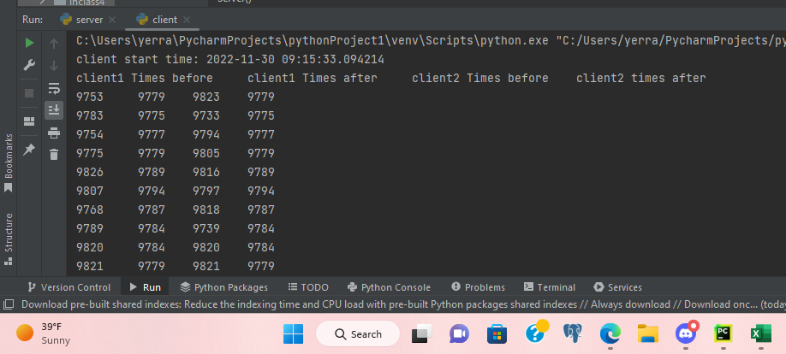

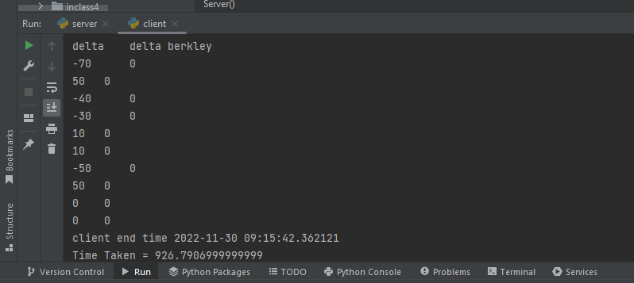

**Worked with: Vamsi**

**References: Geeks for Geeks.**